AquaFlow Proposed System Interfaces
Visual Screenshot Catalogue
This document contains the generated interface visuals as pictures for easy visualization.

Included visuals:
- 1. Full Interface Collage - Page 1
- 2. Full Interface Collage - Page 2
- 3. Dashboard
- 4. Customer Profile
- 5. Create Billing
- 6. Receive Payment
- 7. Service Requests
- 8. Dashboard Overview
- 9. Customer Profile Details
- 10. Generate Billing
- 11. Preview Billing
- 12. Bill Summary
- 13. Bills Listing
- 14. Receive Payment Screen
- 15. Meter Readings
- 16. Work Order Details
- 17. New Customer Registration
- 18. Collection Report
- 19. User Management

Full Interface Collage - Page 1
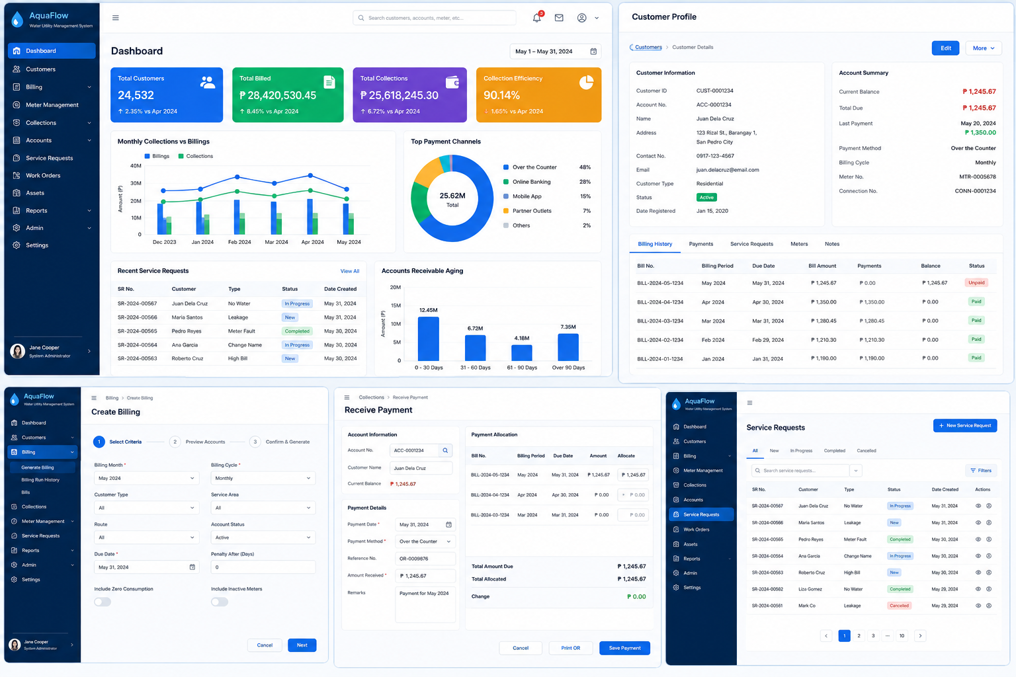
Figure 1: Full Interface Collage - Page 1

Full Interface Collage - Page 2
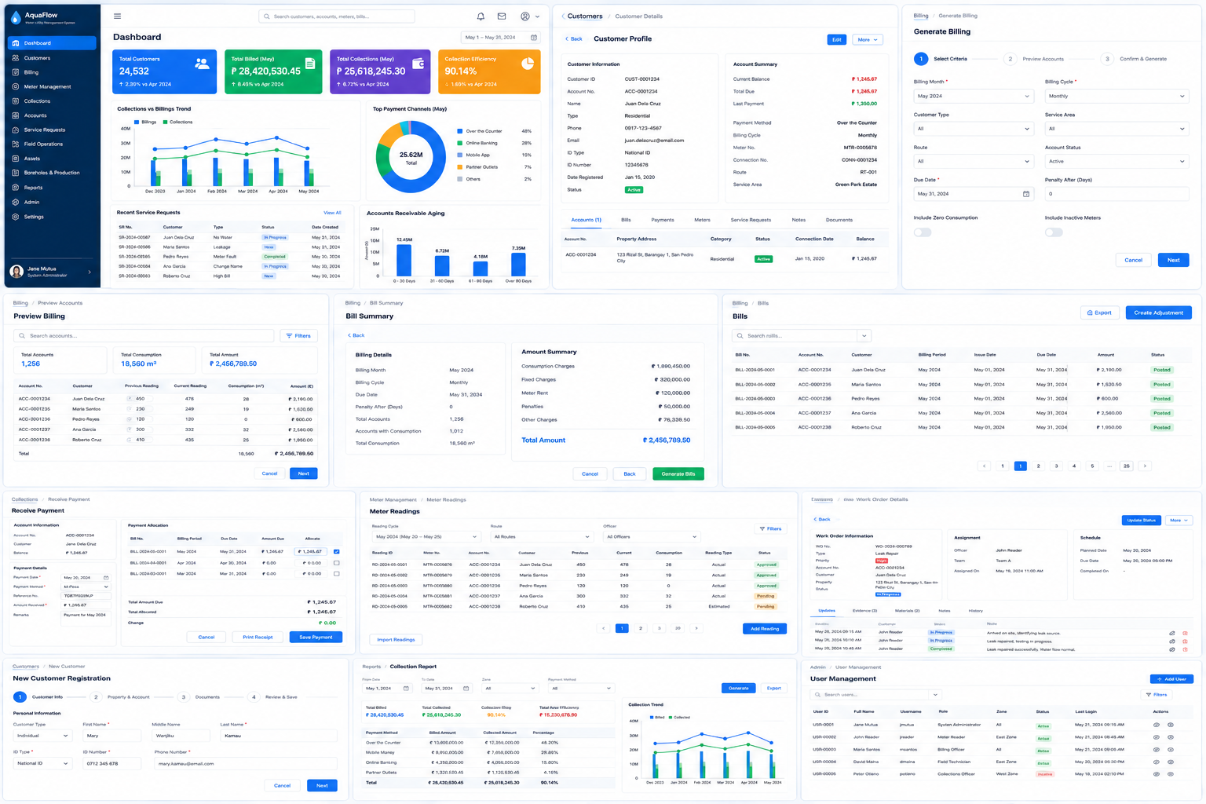
Figure 2: Full Interface Collage - Page 2

Dashboard
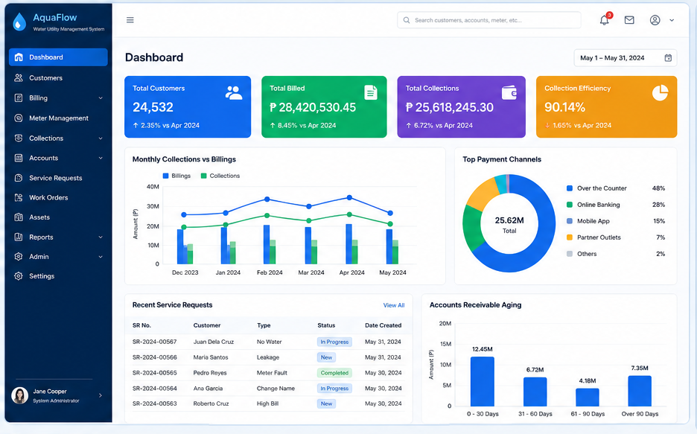
Figure 3: Dashboard

Customer Profile
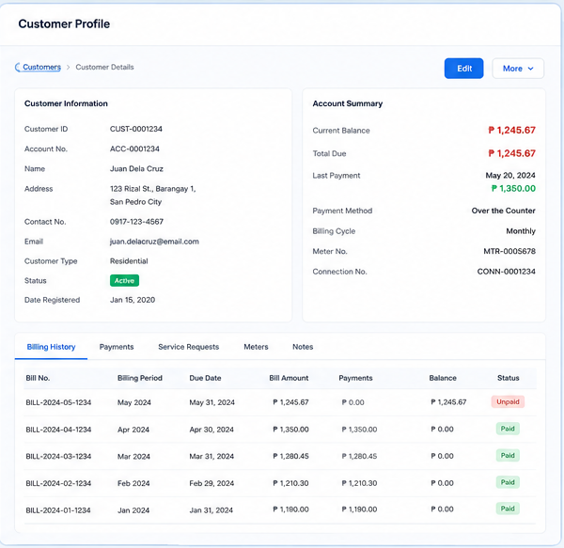
Figure 4: Customer Profile

Create Billing
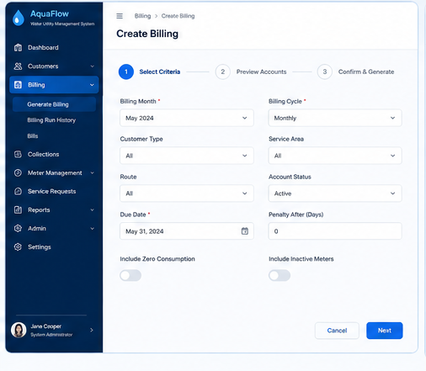
Figure 5: Create Billing

Receive Payment
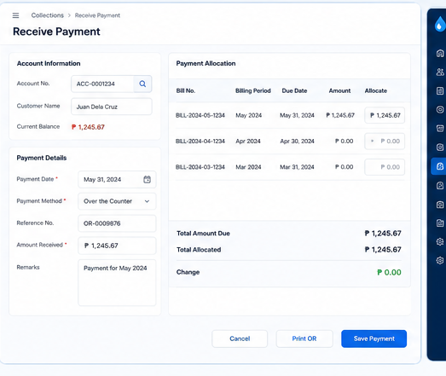
Figure 6: Receive Payment

Service Requests
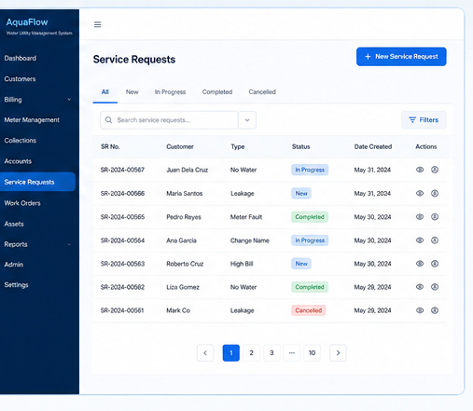
Figure 7: Service Requests

Dashboard Overview
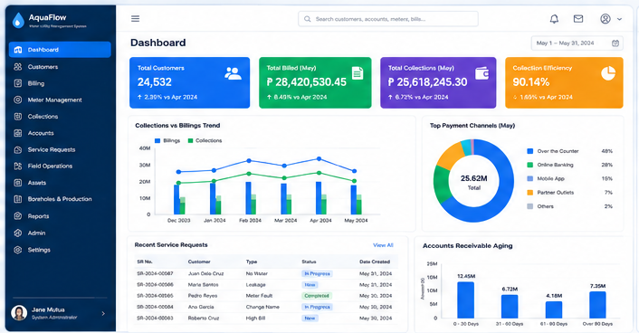
Figure 8: Dashboard Overview

Customer Profile Details
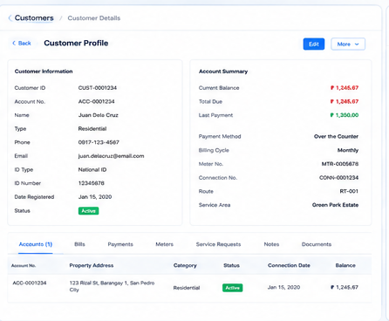
Figure 9: Customer Profile Details

Generate Billing
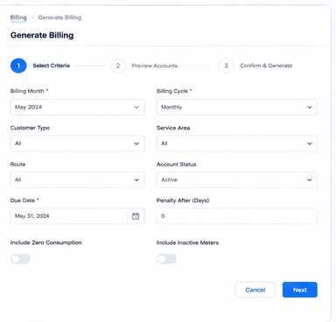
Figure 10: Generate Billing

Preview Billing
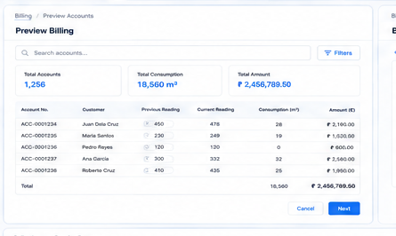
Figure 11: Preview Billing

Bill Summary
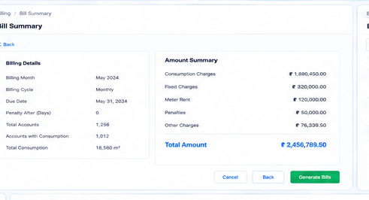
Figure 12: Bill Summary

Bills Listing
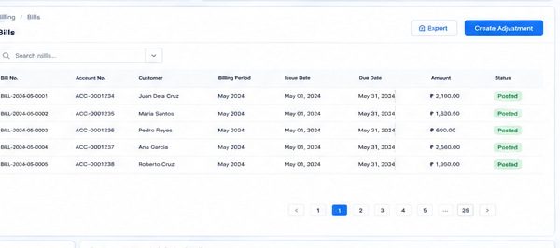
Figure 13: Bills Listing

Receive Payment Screen
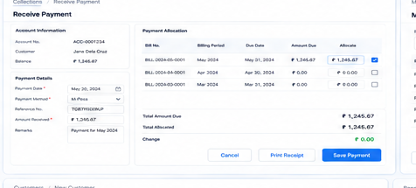
Figure 14: Receive Payment Screen

Meter Readings
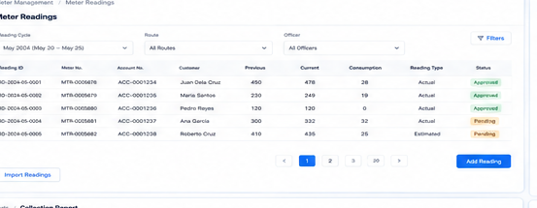
Figure 15: Meter Readings

Work Order Details
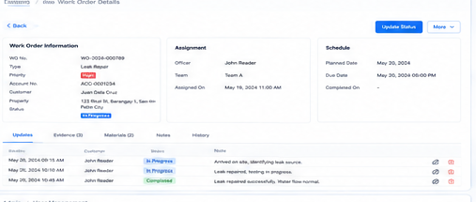
Figure 16: Work Order Details

New Customer Registration
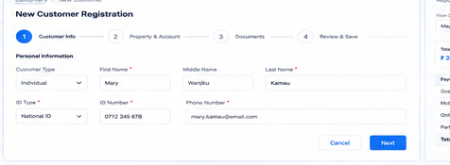
Figure 17: New Customer Registration

Collection Report
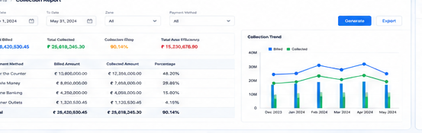
Figure 18: Collection Report

User Management
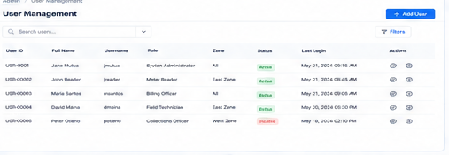
Figure 19: User Management

